|  |
| --- |
| Student Name: Abdallah Daradkeh  Student ID: 21110446  Section #: 4-0 |

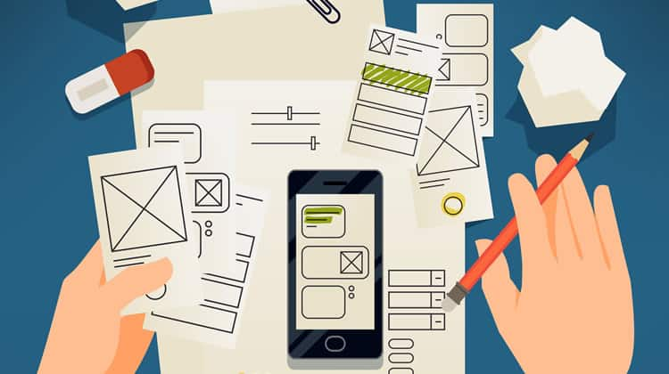

Prototyping

Assignmnet 1

Spring 2022

Contents

**1-** **Different Forms of prototyping** 2

1.1 Discuss the different forms of prototyping, their purpose, their advantages and disadvantages, their testing outcomes. 2

1.2 Review the Standard Prototyping tools by providing a brief explanation about each tool and how they can be used in identifying and testing user requirements effectively. 3

**2-** **Review different end user categorizations, classifications and behavior modelling techniques.** 4

User segmentation: 5

User Persona: 5

**3- Examine available prototyping methodologies to test with a specific end user from the user population.** 6

**4-Prototyping Plan** 6

4.1 Generic Description of Your Product Idea That Is Being Developed. 6

4.2 Identify your product end users by choosing the suitable end user categorizations, classifications (Segmentation, persona canvas, The value proposition canvas, customer journey map….) and behavior modelling techniques (BJ Fogg’s Behavior model), **choose the suitable ones not necessarily all of them.** 6

4.3 Determine the suitable methodology (Rapid throwaway prototype Evolutionary prototype Incremental prototype Extreme prototype), **choose the suitable one.** 6

4.4 Outline the right tools to prototype your idea (example, JustInMind, Figma, Mockups…) 6

4.5 Plan your prototype evaluation methods (Testing methods: Usability Testing, Focus Groups, beta Testing, A/B Testing, Surveys), **choose the suitable ones not necessarily all of them.** 6

**5-evaluate the impact of common prototyping methodology within the software development lifecycle.** 7

**6-Low-fidelity Wireframe** 7

6.1 Wireframes screenshots before applying feedback. 7

6.2 Iteration 1 7

6.2.1 Feedback – outline the end users’ feedback on the first iteration of your wireframe. 7

6.3 iteration 2 7

6.3.1 Feedback – outline the end users’ feedback on the second iteration of your wireframe. 7

6.4 Screenshots after applying feedback (of the updated wireframes only) 8

**7-Mid-fidelity Mock-up** 8

7.1 Mockups screenshots before applying feedback. 8

7.2 Iteration 1 8

7.2.1 Feedback - outline the end users’ feedback on the first iteration of your Mockup. 8

7.3 iteration 2 8

7.3.1 Feedback- - outline the end users’ feedback on the second iteration of your Mockup. 8

7.4 Screenshots after applying feedback (of the updated mockups only). 8

**8-** **High-fidelity Prototype** 8

8.1 Outline the added features to build your high-fidelity prototype. (What are the interactions, validations added to your prototype to make it similar to the final product) 9

8.2 Review end-user feedback from multiple iterations of your prototype and justify the updates to the final prototype based on end user feedback and testing. 9

**9-** **Critically evaluate the prototype against the original plan and how user feedback and testing was implemented.** 9

**References** 9

# **Different Forms of prototyping**

## 1.1 Discuss the different forms of prototyping, their purpose, their advantages and disadvantages, their testing outcomes.

* **Low Fidelity User Prototypes**: They are created early in design process, it used in order to exploare ideas, and they used to communicate ideas and gather feedback, and also in order to test concepts(value proposition) before move on to high effort on the development stage or into detailed design. It use to test and validate the workflow of their application through created interactive wireframes, also simulates the process to address issues related to usability early. And in order to test how a feature works, navigation structures, the placement of content (also check usability)
* **High-fidelity user prototypes**: They are designed it which it is very similar to how the final product is going to be, it is need a lot of time to be designed since it contains a lot of advance details. They includes visual design elements and they have interactive features, and realistic content to have realistic user experience. It is test the usability, in order to test concepts that are not disucssable, but we can do it in a way which is better. And it allow to a more realistic usability testing. And allows user experience evaluations testing. And we do that by providing a realistic content with a visual design provided with interactions which are very similar to the final product.
* **Feasibility Prototype**: We use it When we are made prototype for a new technology, we are focusing on evaluating technical and functional feasibility of the system. We implement it in order to determine if we can implement a specific idea(Can we continue developing it). We just focus on the essential features and on the necessary functionality which are necessary to prove the feasibility of the idea(we omit any non-necessary details). We use it to test the technical limitations through validate the intended functionalities and features and also ensure that they are achieving the desired goal from them. So this is also test if it is meeting end user requirements by building this prototypes with the essential functionalities if it is meeting them. It is validating many thing such as(scalability, performance, compatibility,…). And it can be use to gather user feedback and validate his requirements(end user). So this will allow us to early addressed any issues (usability, preferences) that are ( the gaps between the prototype and the desired end user requi9rements.

**Live-data Prototypes**: These prototype is special because we collect here an actual data so we can get out with some results and some conclusion, So through accessing live data sources and sending of live traffic to the prototype to get a data that is beneficial and useful and it is such a some of proofs that the feature or the design approach is actually work. However, these advantages allow us to test specific functionalities and see by evidence if functionalities are work and if it is meeting end user requirements. But even if it is goes will we can’t consider it as the final product, because there are still a lot of issues that lack live data prototype to become a product such as scalability, SEO, Robustness, polish.

## 1.2 Review the Standard Prototyping tools by providing a brief explanation about each tool and how they can be used in identifying and testing user requirements effectively.

* Figma: (High Fidelity too, you can lead the whole design process with it)It is cloud-based design and prototyping tool, it is enables real-time collaboration, also it is enable iterative design. Some features its offers: vector editing, design components, interactive prototyping. It allows designers to create and manage libraries and components. Which make it easier to ensure consistently throughout the product. Reeal time user testing by sharing the protiotype with end users remotely, this help and allow to observe how users are using the prototype and interact with and gather feedback and validate user requirements.
* InVision: (High Fidelity too, you can lead the whole design process with it) It is a prototyping and collaboration tools. Create prototypes which are provided by interactive feature, and share these prototypes with stakeholders and end users. It offers many features:such as hotspots, animations and user flow diagrams. It is provide a realistic interactive experience that simulates the final product. It is enable designers to create interactive prototypes which make the user go through experience which it is very similar to the experience of the final product. Designers can determine interactions and animations. This allow for effective testing and validation of user requirements . Prototypes can be shared by desingers with team members and end users and stakeholders, they can communicate and provide feedback and go in a discussions. This help to refine user requirements based on multipe point of view. InVision provides many featurews for managing and user testing, for example: it has screen recording and real-time collaboration and more which allow designers to share prototypes with end users and monitor there using to the software, so gather feedback and validate user requirements, since they can made usability testing.
* JustInMind: (High Fidelity too, you can lead the whole design process with it)it is a very powerful prototyping tools which allow designers to create interactive prototypes, and with a lot of interactions, animations and dynamic content. Features: drag and drop feature, Libraries full of pre-built user interface components. It is used to create interactive prototype which allows designers to test and gather feedback on the interactions, the flows of user, the usability overall. It is provides collaboration features wich allow designers to share protoypes with end users for feedback and also with stakeholders to feedback. This help to validate and determine user requirements effectively. Also it support conditional interaction, that the prototypes behavoir can change based on a change of something or on a specific conditions, this enable designers to test different possibilities and scenarios and ensuring complete and fulfil user requrirement

# **Review different end user categorizations, classifications and behavior modelling techniques.**

User segmentation:

It is to divide people into segmentations based on common characteristics between them, so each group with a common characteristics we take it into a single segmentation and so on. And this help organizations to choose the marketing staragegies that they want to use with their customers while they know them better, and tagrget them with suitable products and services. So, They can make touches and interactions with their customers in a way which is more relevat and more personalized.

There are many criteria which we can take it as a common factors between users such as: Demographic, Geographic and lifestyle segmentation,… .

Personas: So this is a canvas help us to show matters from the customer view and to put us in his shoes, By representation their customers information, so the talking about customers characteristics become more beneficial and it make it easier to find a common pattern of their characteristics. So with user personas it helps a lot in design and development process, since you know in the first place who are you designing for. Since you become know your users interest, expectations, motivations. So by knowing these characteristics it is help you to design a product which satisfy users needs.

By persona you got a broad perception and understanding of your users(who are they), and also their behavior and needs, and see issues from the users point of view not from your company members and their families. So many things in business become focused and better and more effective such as: conversations and decision making become clearer and far better and business meetings. And this raise the quality of your products and services your design team and projects managers make and make them tailored to their users

# **3- Examine available prototyping methodologies to test with a specific end user from the user population.**

* Evolutionary prototyping methodology: It is an iterative software development approach which go through multiple iterations, so the prototype is refined based on user feedback until accepted solution is reached. To test a specific end user we can based on the behavioral models and techniques we have done before deal with them more accurately, then in this approach we create initial prototype, So this prototype represent the basic functionalities that the system must include. Then make the end user testing. So, you can make it as focus group or beta user testing, then you gather feedback from users and refined prototypes based on it. And as you continue to go through more iteration and use different type of testing and refined the prototype. Until you finalize the development process.
* Incremental Prototype Methodology: In this methodology separate parts merged together to make the final product. So small prototypes seperatelty are built in parallel. Each one of these prototypes are evaluated by the user and refined based on his requirements, then they are all merged together. This prototype allows user to focused on testing specific functionalities each iteration.
* Rapid Throwaway Methodology: It is a prototype methodology, which involves exploring ideas. This is happening through quick development to the prototype based on customer preliminary requirements then it is continuous correct by customer feedback. Why it called throwaway? Because actually on each interaction from the customer we through the current prototype, and start making new prototype from the scratch. So we see user interactions and feedback on the prototype through testing sessions then we finally reached to gained insights which will be used to the final product development separately.
* Extreme Prototyping: This methodology helps in web development, it contain three stages/phases: static pages written in HTML mainly, the screen are programming and provided with fully functional through services layer simulation. So, we get the user in testing the prototype, we provide them with scearios to perform on the prototype. Then we observe their interactions and show their feedback and concerns and their improvements suggestions. So we use this feedback to refine and iterate the prototype.

# **4-Prototyping Plan**

## Generic Description of Your Product Idea That Is Being Developed.

My idea is "MySchool" application, it is an application which give some educational services such as( the nearest school, schools details/buget/books/required tools).

It will be an application, which user will go into and create an account for them, then based on their location, the application will show them the nearest school to them. Also they have the ability to made add/update delete schools on the app, but this processes will not be done directly, it will be checked by the application organisation to check the validity of this changes.

There are not competitors in this pariculer idea, maybe there are in the education field services, but this service to get the nearest school, there is no competitor.

It is find the problem of families and student so they can find the best school to them in terms of budget/service/distance/…

## Identify your product end users by choosing the suitable end user categorizations, classifications (Segmentation, persona canvas, The value proposition canvas, customer journey map….) and behavior modelling techniques (BJ Fogg’s Behavior model), **choose the suitable ones not necessarily all of them.**

## User segmentation:

|  |  |  |
| --- | --- | --- |
| **Segmentation types** | **Segmentation Chosen Ex: age, region, …etc.** | **Segmentation criteria Ex: age>18, region=Amman, …etc.** |
| Demographic Segmentation | Income level | Any income level |
| Geographic Segmentation | Country | Jordan |
| Lifestyle Segmentation | Interests | Local schools |
| Behavioral Segmentation | Navigation patterns | The most will known navigation patterns |

## User Persona:

## Determine the suitable methodology (Rapid throwaway prototype Evolutionary prototype Incremental prototype Extreme prototype), **choose the suitable one.**

zEvolutionary prototype: It is prototype that has the development process in incremental and iterative nature. In order to allow to continuous refinment and improvement based on user feedback and the requirements that change.

Our requirements are not well-defined and it is going to go through frequent changes

* **I choose Evloutionary prototype as our prototype methodology.**

## Outline the right tools to prototype your idea (example, JustInMind, Figma, Mockups…)

Tool I will use: JustInMind

## Plan your prototype evaluation methods (Testing methods: Usability Testing, Focus Groups, beta Testing, A/B Testing, Surveys), **choose the suitable ones not necessarily all of them.**

* The evaluation will be done on prototype starting by:
* Evaluation on low-fidelity prototype which will include
  + Evaluate based on the completed functionality, through watching how much are those completed functionality.
  + Evaluate throughout the end user by making him interact with the prototype through making focus group showing them the prototypes and how we moving fom one page to another to get out with system needs and lacks and essential notes.

I sea the user the wireframe pages:

* Evaluation on mid-fidelity will include:
  + Evaluate it through showing the prototype to sample of users to know the best case to the position of elements through A/B testing.

A brief about the test

A)

B)

And B was the best choice based on customer feedback

* Evaluation on High-fidelity will include:
  + Evaluate it through moderated testing, by make a sessions and get feedback from them about usability, functionality, and user experience and their opinion about interactions and pages layout, etc.

# **5-evaluate the impact of common prototyping methodology within the software development lifecycle.**

Evolutionary prototype:

This methodology **improved the level of requirements validation and verification**, since it is gives an **iterate approach to gather feedback and refine prototypes based on customer feedback**. This iterative refinement **provides flexibility and adaptability**. And it is include **continuous improvement throughout SDLC Through developme**nt, **testing and feedback cycles**, so we can a**ddress issue on functionality or in an aspect of the prototype and refine that issue**. It **allows customer to engage and collaborate** in the development process and in all SDLC phase. This is enable **customers better understand** to the system and **include customers valuable feedback** on the development process and **meeting their expectations**. And also it **is break down the development of process into smaller iterations** so it can be manageable easily. And **every iteration has to be tested and evaluated**, this gives the opportunity **to address issues early on**. **reducing the risk for allover the project** and **increase opportunities for success**. An also **increments development gives higher qualit**y since we **can focus on gives high quality improvements in each iteration.**

# **6-Low-fidelity Wireframe**

## 6.1 Wireframes screenshots before applying feedback.

## 6.2 Iteration 1

### 6.2.1 Feedback – outline the end users’ feedback on the first iteration of your wireframe.

Updated application pages

Homepage: There is no header

Search For School: There is no header

School Addition/update: There is no header

First school info: There is no footer

Addition new School: There is no footer

Update school info: there is no footer

Update Done: there is no footer

School has been submitted: there is no footer

School has been deleted: there is no footer

## 6.3 iteration 2

### 6.3.1 Feedback – outline the end users’ feedback on the second iteration of your wireframe.

There is no feedback this iteration

## 6.4 Screenshots after applying feedback (of the updated wireframes only)

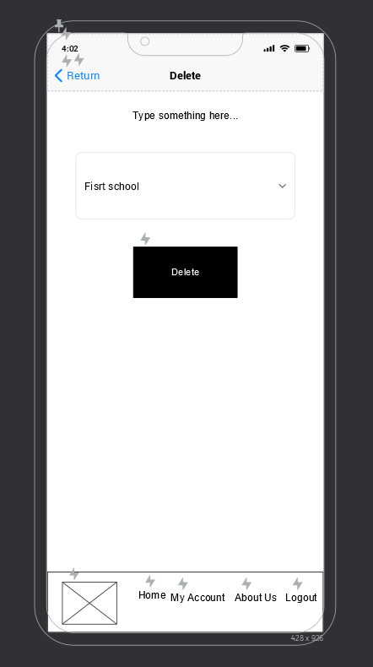

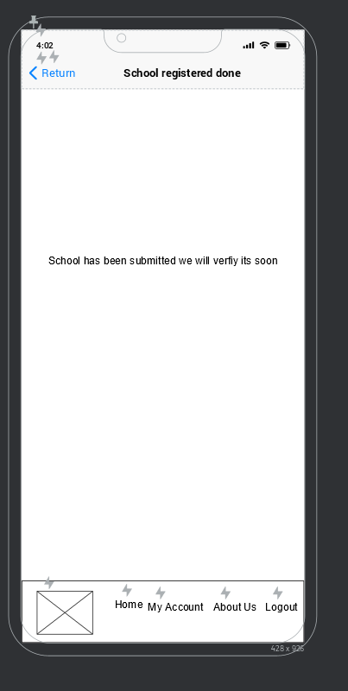

# **7-Mid-fidelity Mock-up**

## 7.1 Mockups screenshots before applying feedback.

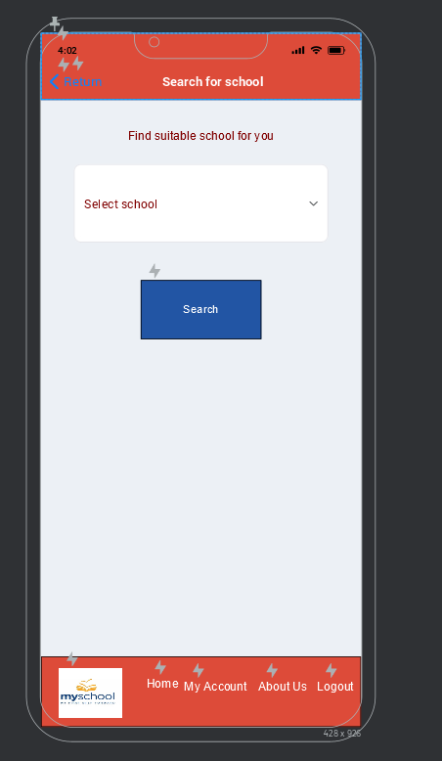

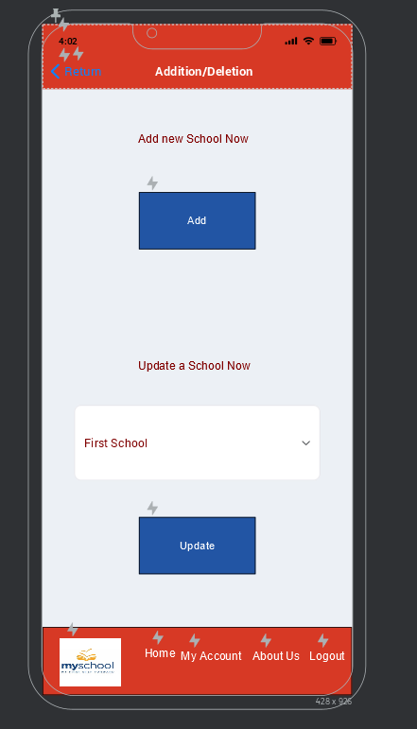

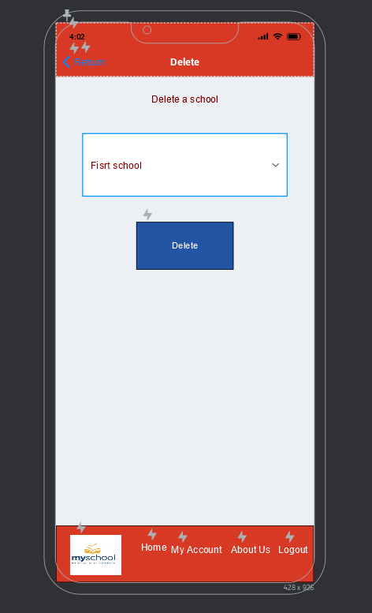 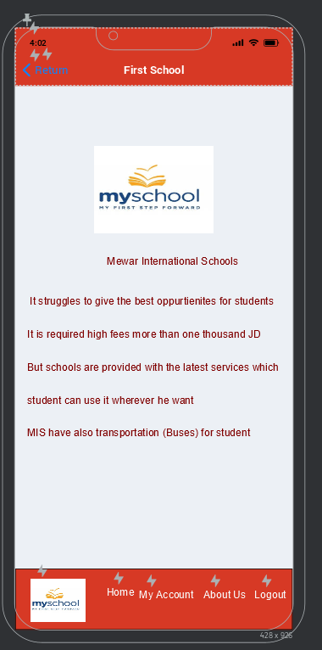 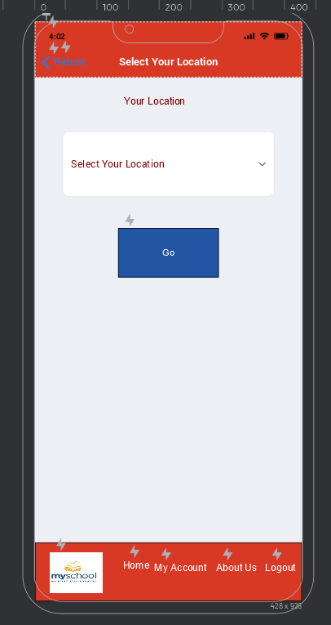 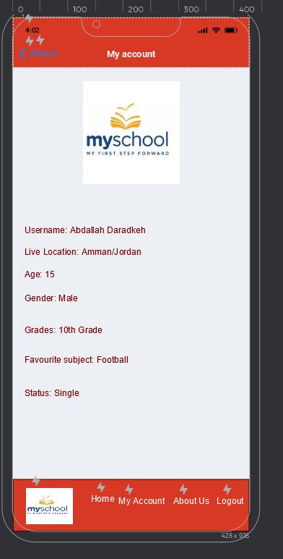 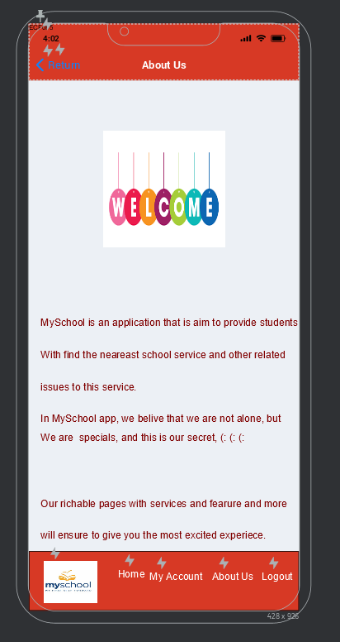 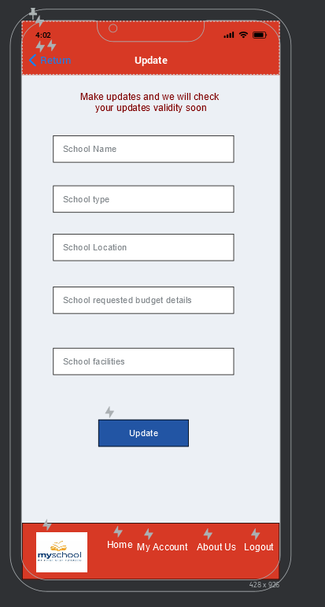

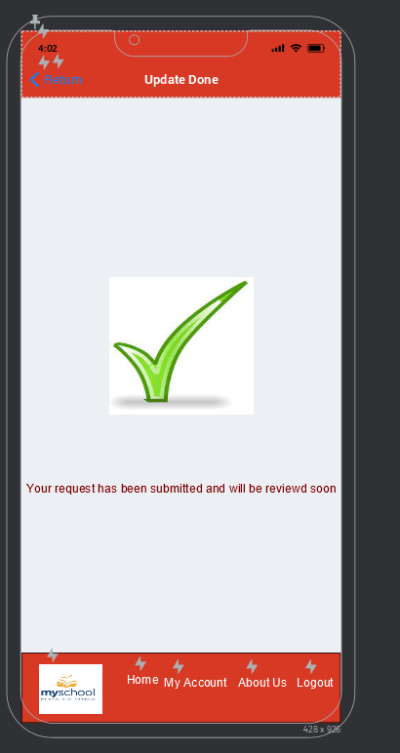

## 7.2 Iteration 1

### 7.2.1 Feedback - outline the end users’ feedback on the first iteration of your Mockup.

* About us page: image is not suitable.

## 7.3 iteration 2

### 7.3.1 Feedback- - outline the end users’ feedback on the second iteration of your Mockup.

There is no feedback in this iteration

## 7.4 Screenshots after applying feedback (of the updated mockups only).

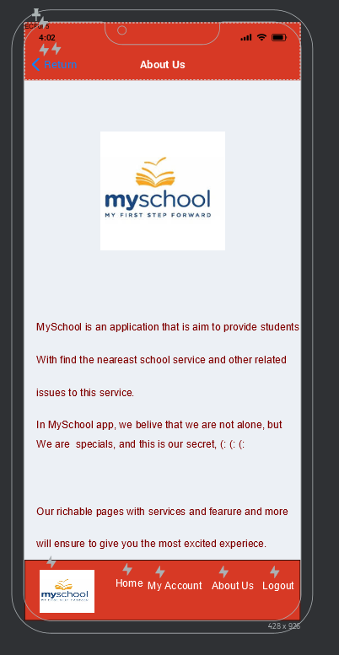

# **High-fidelity Prototype**

## 8.1 Outline the added features to build your high-fidelity prototype. (What are the interactions, validations added to your prototype to make it similar to the final product)

Here is explain the interactions, such as enter (the login page if the user press on login button wil access hem to the home page and so on)

Interactions:

* Splash page: when you enter to the splash page it will take you a few moments to take you to the login page.
* In Login page: it is just like all other login pages in the world, just enter username and password then you will enter to the application, You must create a user from sign up page.
* Sign up page: in this page you enter your account information and validation information(username and password) then you click sign up. Click sign up will take you to the login page to login with the account that you have been created.
* HomePage: In home page, you can access to the main features of the app, you can click on images or texts which will take you to the necessary pages to complete the desirable action. So Search school image and text will take you to Select Your Location page where you will choose the location of school you want to look for. And Add/update school image and text will take you to school Addittion/update school where the necessary resources for add or update a school are there. Press the Delete school text or image will take you to Delete School page to complete delete school process. In addition there are also common interactions exists in home page which are exists in all other pages of the application except the login and sign up page (which are two bars ( Header and Footer)) in the header the name of the page in other pages there are exist return text in the header which take you to home page if you click in. In the footer there are many buttons( Home text and logo picture take you to the HomePage, My Account text take you to My account page, About Us take you to About Us page, Logout text take you out of the application.
* Search for school: Except common Header and footer between all pages which are exist. There are The list of school to choose from and Search button which will take you to First School page to show the school information.
* School Addition/update: in this page there are Two buttons Add button which take you to Addition new school page to fill the desirable school to be added information to submit. And Update button which take you to Update school info to enter new information of the school. And also there is a list of school to choose the desirable school to update.
* Delete page: There is list of schools to select the desirable school to delete. There is a delete button which take you to School has been deleted page, which tell the user that the app will chick the validation of the action he takes.
* First School info page: include school searchable information.
* Select Your Location page: it includes lest of locations that user wants the school in. And a button Go which user click it and it takes it to the schools that it found in his area to the Search for school page
* My account page: include user information
* About us page: includes information about application and application owners and other related information.
* Addition new school: You enter school information here that you want to add. There are set of text boxes to fill information of the school and Submit button which will take you to school has been submitted.
* Update school info: In this page there are many text box to fill school new information and a Update Button which take you to Update Done page.
* Update Done page: it tell the user that updated has been done.

## 8.2 Review end-user feedback from multiple iterations of your prototype and justify the updates to the final prototype based on end user feedback and testing.

I have done many iterations:

1) Customer gives feedback on most of pages on Wireframe that they don’t have header, and the rest don’t have footer, So I put a header and footer for the pages that need.

2) Customer gives feedback on mockups that the Picture at About us was not suitable because I was putting the logo’s Application on it, so they prefere it to be change with different picture, So I make this change, it was really a valuable feedback, and yes, it was not a suitable picture to an About Us page.

3) Based on A/B testing I have changed the place of MySchool Logo in login page, based on customer evaluation and feedback, since it become more user friendly and more suitably in terms of vision.

# **Critically evaluate the prototype against the original plan and how user feedback and testing was implemented.**

In the prototype, I make everything as the plan approximately since I :

1) Get sticked to the evolutionary prototype methodology, since I go through increments development process, Gather requirements from user then make quick low fidelity prototype, then evaluate, then refine. And I do that also with medium fidelity prototype and high fidelity prototype.

2) I stick to the most of user segmentation method and personas I have made, so I enter local schools in Jordan school in the app, also I used well know patterns to the navigation and apps elements,… but there is still some issues I did not address, but I focus on addressing the main issues to end user.

3) I also use JustInMind in the whole process as a tool to design the desirable prototype

4) According to the testing process, I implement A/B testing in mock ups to show what is the best location and case for some elements in the application. And this is how the implementation was:

A case:

B)

And B was the best choice based on customer feedback

5) Unmoderated test and moderated test has been done, but I did not document them or save them.

6) The user feedback was implemented in a very good manner, In each iteration we were taking feedback from users and refine on prototype.

7) the testing goes very well, we refine prototype and make necessary requirements and detect uncovering issues.

In conclusion, I approximately stick to the plan, but there are some point I did not follow as the plan, which must be given into consideration in the future to be checked and reviewed.

# **References**